Name: Krushna Garole Roll.No.: C32257 Div: 2
(Information Security)

Assignment No. : 1
s = "Hello\nWorld" print("Original String:") print(s)
# AND operation and_result = "" for ch in s:
and_result += chr(ord(ch) & 127) print("\nAfter AND with 127:") print(and_result) # XOR operation xor_result = "" for ch in s:
xor_result += chr(ord(ch) ^ 127) print("\nAfter XOR with 127:") print(xor_result)

Output:
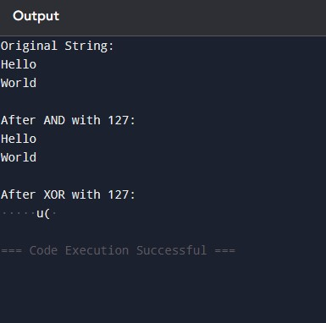
Name: Mayuri Kad Roll.No.: C32248 Div: 2
(Information Security)

Name: Krushna Garole Roll.No.: C32257 Div: 2

Assignment No. : 2
def encrypt(text, key): res = [""] * key row = 0 step = 1 for ch in text: res[row] += ch if row == 0: step = 1 elif row == key - 1:
step = -1 row += step return "".join(res) def decrypt(cipher, key): n = len(cipher) pattern = [0] * n row = 0 step = 1 for i in range(n): pattern[i] = row if row == 0: step = 1 elif row == key - 1:
step = -1 row += step res = [""] * n index = 0

for r in range(key): for i in range(n): if pattern[i] == r:
res[i] = cipher[index] index += 1
return "".join(res)

# main text = input("Enter text: ") key = int(input("Enter key: ")) c = encrypt(text, key) print("Encrypted:", c) print("Decrypted:", decrypt(c, key))

Output :
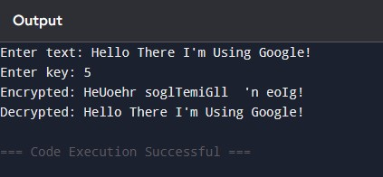

Name: Krushna Garole Roll.No.: C32257 Div: 2
(Information Security)

Assignment No. : 3
# Simple DES-like (using XOR) def encrypt(text, key):
result = "" for i in range(len(text)):
result += chr(ord(text[i]) ^ ord(key[i % len(key)])) return result def decrypt(cipher, key):
result = "" for i in range(len(cipher)):
result += chr(ord(cipher[i]) ^ ord(key[i % len(key)])) return result
# Main text = "HELLO" key = "KEY"
enc = encrypt(text, key) print("Encrypted:", [ord(c) for c in enc]) dec = decrypt(enc, key) print("Decrypted:", dec)

Output:
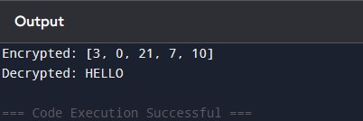

Name: Mayuri Kad Roll.No.: C32248 Div: 2
(Information Security)
Name: Krushna Garole Roll.No.: C32257 Div: 2

Assignment No. : 4
# AES Algorithm (Simplified using XOR logic)

def encrypt(text, key):
result = "" for i in range(len(text)):
result += chr(ord(text[i]) ^ ord(key[i % len(key)])) return result

def decrypt(cipher, key):
result = "" for i in range(len(cipher)):
result += chr(ord(cipher[i]) ^ ord(key[i % len(key)])) return result

# Main text = "HELLO" key = "SECRET"

print("Original Text:", text) print("Key:", key)

# Encryption enc = encrypt(text, key) print("Encrypted:", [ord(c) for c in enc])

# Decryption
dec = decrypt(enc, key) print("Decrypted:", dec)

Output:

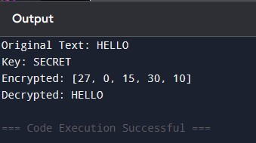

Name: Krushna Garole Roll.No.: C32257 Div: 2
(Information Security)

Assignment No. : 5
# RSA Algorithm (Simple Version)

# Step 1: choose two prime numbers p = 3 q = 11

# Step 2: calculate n and phi n = p * q phi = (p - 1) * (q - 1)

# Step 3: choose e (public key) e = 7

# Step 4: find d (private key) # d * e % phi = 1 for i in range(1, phi): if (i * e) % phi == 1:
d = i break

print("Public Key (e, n):", (e, n)) print("Private Key (d, n):", (d, n))

# message msg = 9 print("Original Message:", msg) # Encryption: c = (msg^e) % n c = (msg ** e) % n print("Encrypted Message:", c)

# Decryption: m = (c^d) % n m = (c ** d) % n print("Decrypted Message:", m)

Output :
